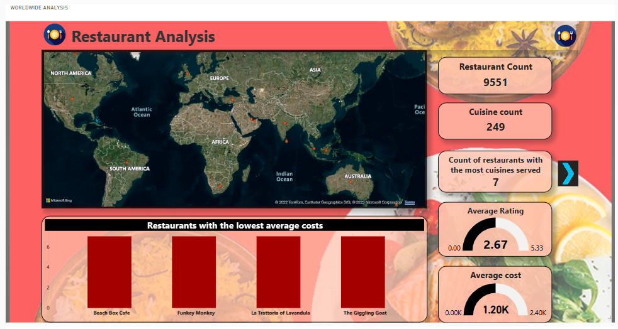

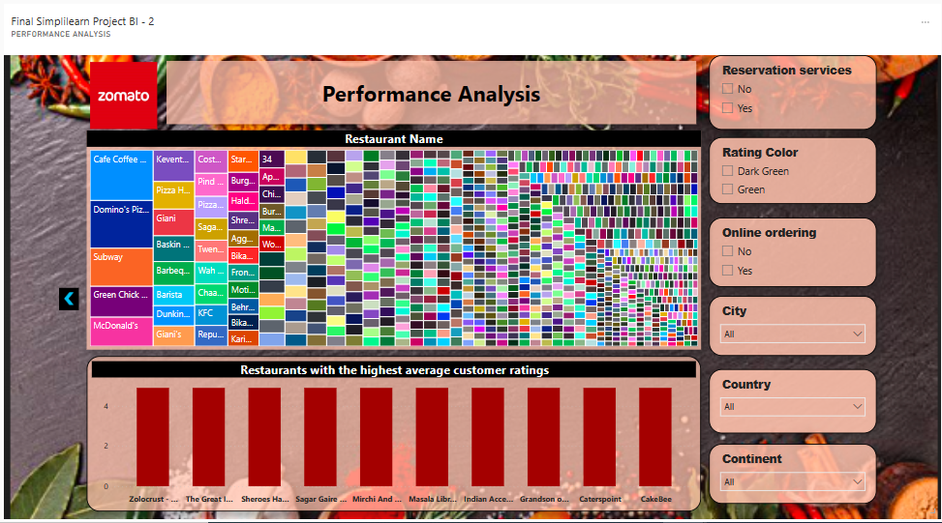

URL: <https://app.powerbi.com/groups/me/dashboards/0f94e5d0-bc95-4b62-94a8-a58cfbb38185>

There are 9551 restaurants and 249 cuisine counts in the world which can be filtered according to state, country and continent. The below bar chart displays restaurants with the lowest average costs. The charts can be filtered bases on online ordering or reservation services, average rating slab by the color, as continent, country, and city. Rating above 4.5 is detonated with Dark Green color and 4 to 4.4 is Green color. The 2nd page of dashboard displays the highest average customer ratings.